**Student Depression Analysis**

**Objective: Extract insights using visual and statistical exploration**

**Dataset:** This dataset is student depression is a CSV file and contained various columns around 27000 rows and it has downloaded from Kaggle.

**Libraries:**

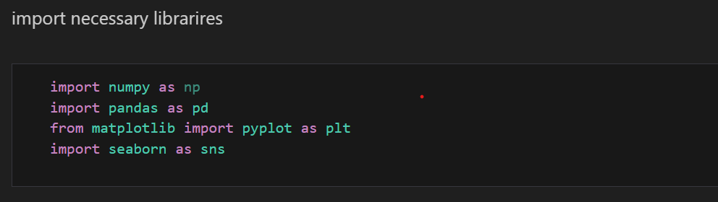

These all are the necessary libraries in the python for helping in exploratory data analysis.

**Check data:**

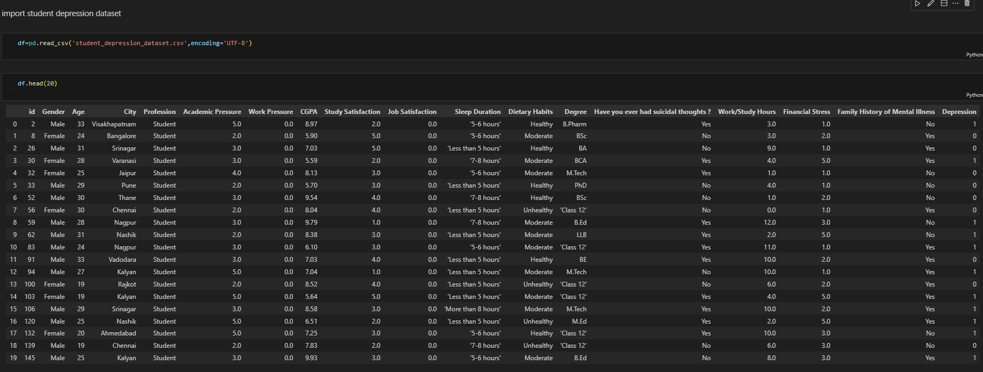

**Change columns data types:**

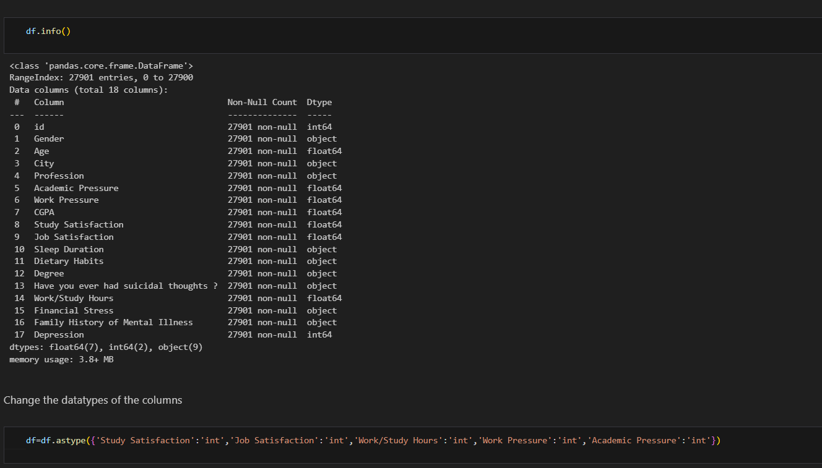

It is necessary to change column data type with their relevant data types.

**Convert Categorical values to numerical values:**

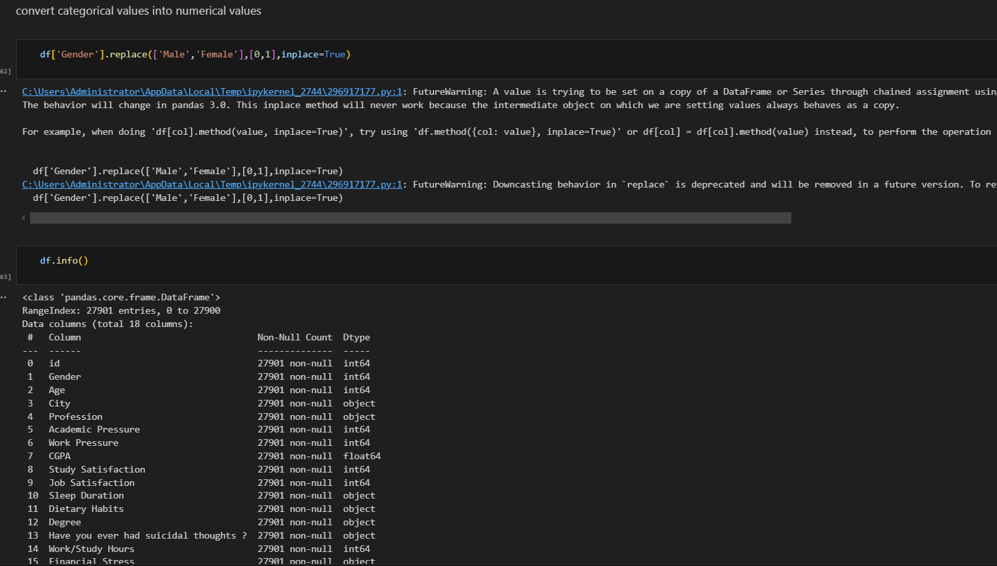

**Check NULL Values**

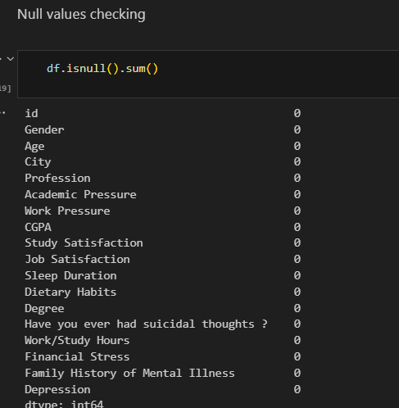

**Exploratory Data Analysis:**

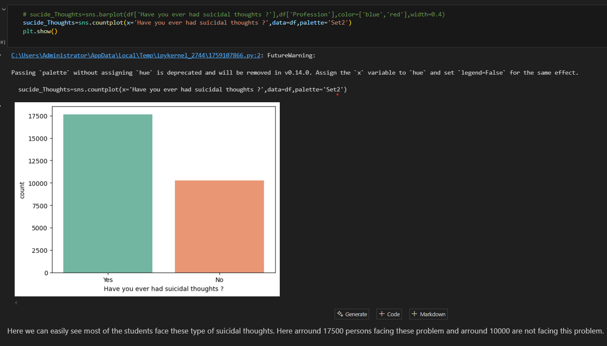**Checking over the dataset how many students are facing “suicidal thoughts”**

**Sleep Duration Impact on suicidal thoughts frequency**

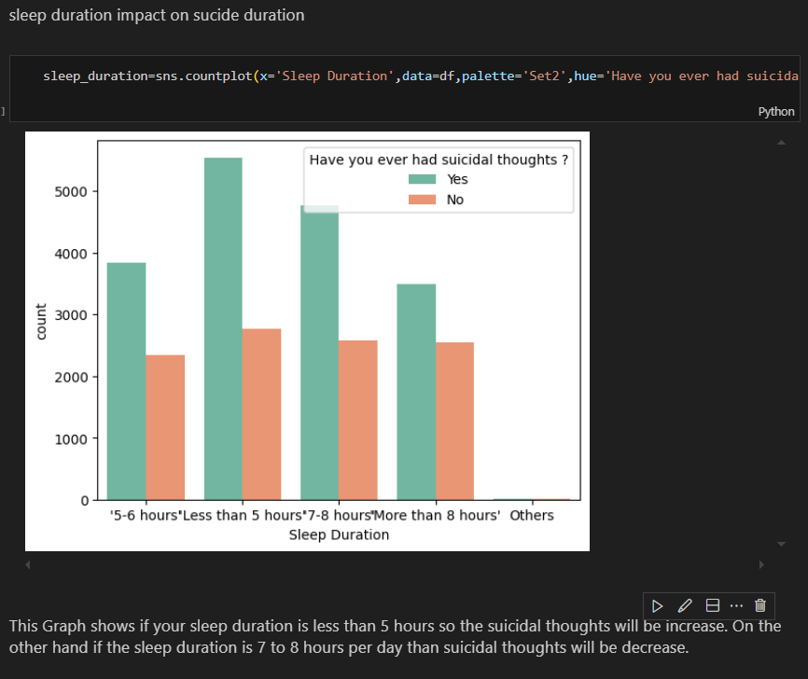

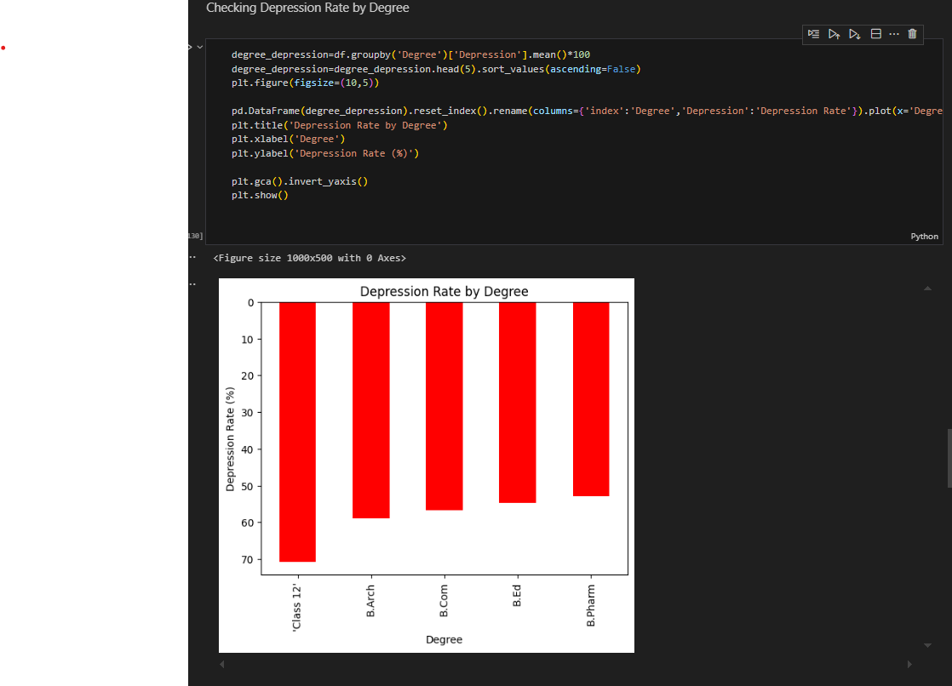**Depression Rate by Dietary Habits**

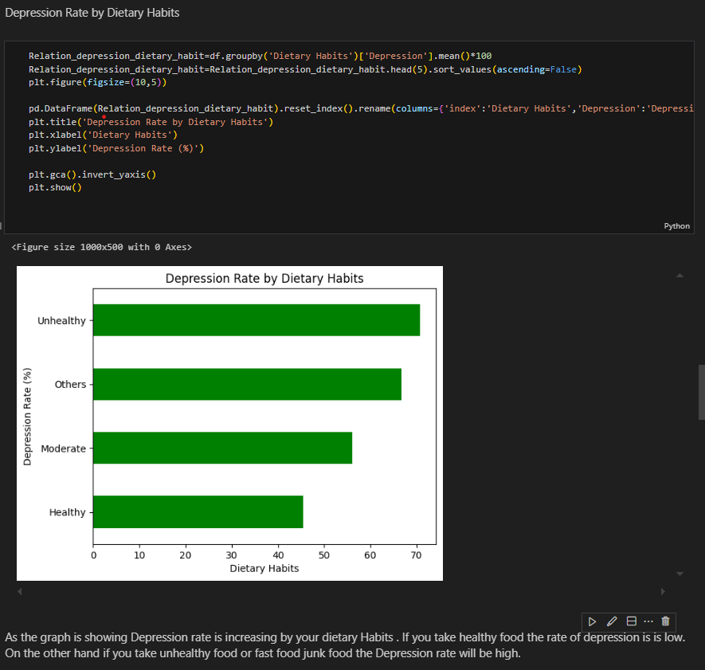**Depression Rate by Dietary Habits**

**Depression Rate by Profession:**

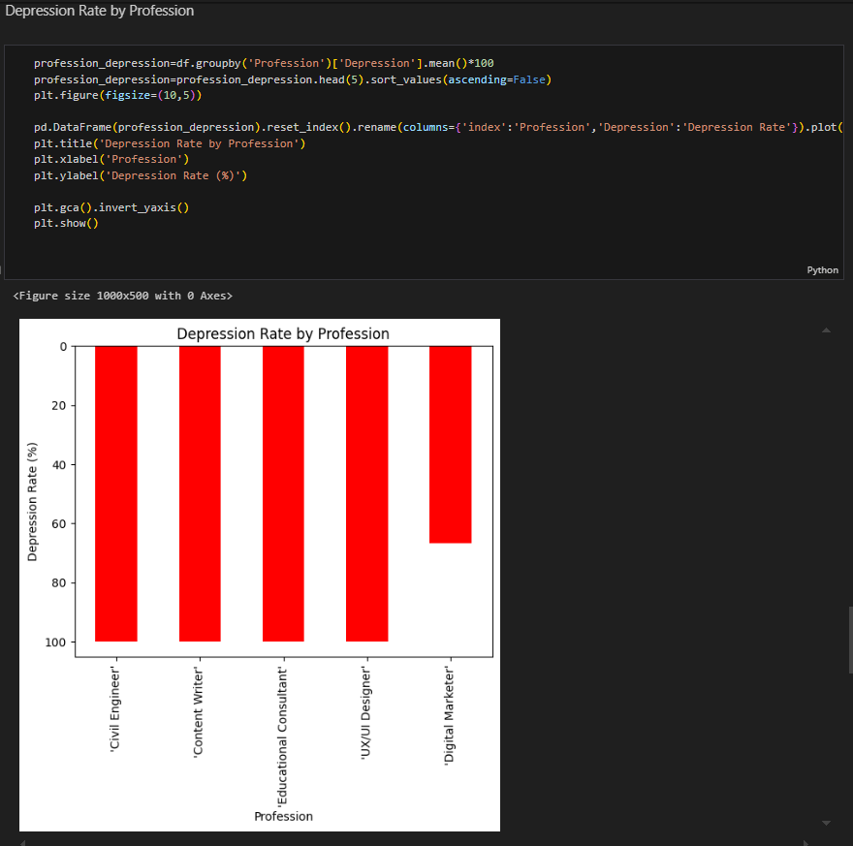

In above graph showing that different-different profession has different depression rate. The graphs shows in the civil engineer profession has higher depression rate as compare to others.

**Top 10 Cities with Highest Students Depression Rates:**

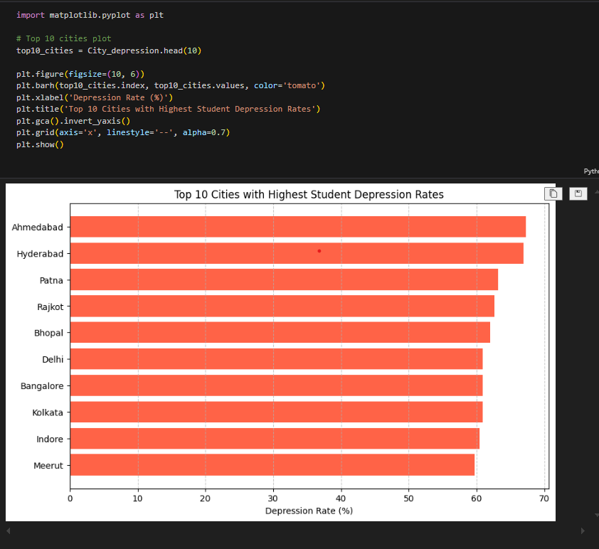

IN this graph Ahmedabad city and Hyderabad and patna has highest student Depression Rates.

**Summary: in this Exploratory data analysis project I have gained some insights that the degree, job pressure ,sleep duration, dietary habits all impacts on the students and job persons health and increase their Depression level and commit to sucide this could be the reason.**

**END**